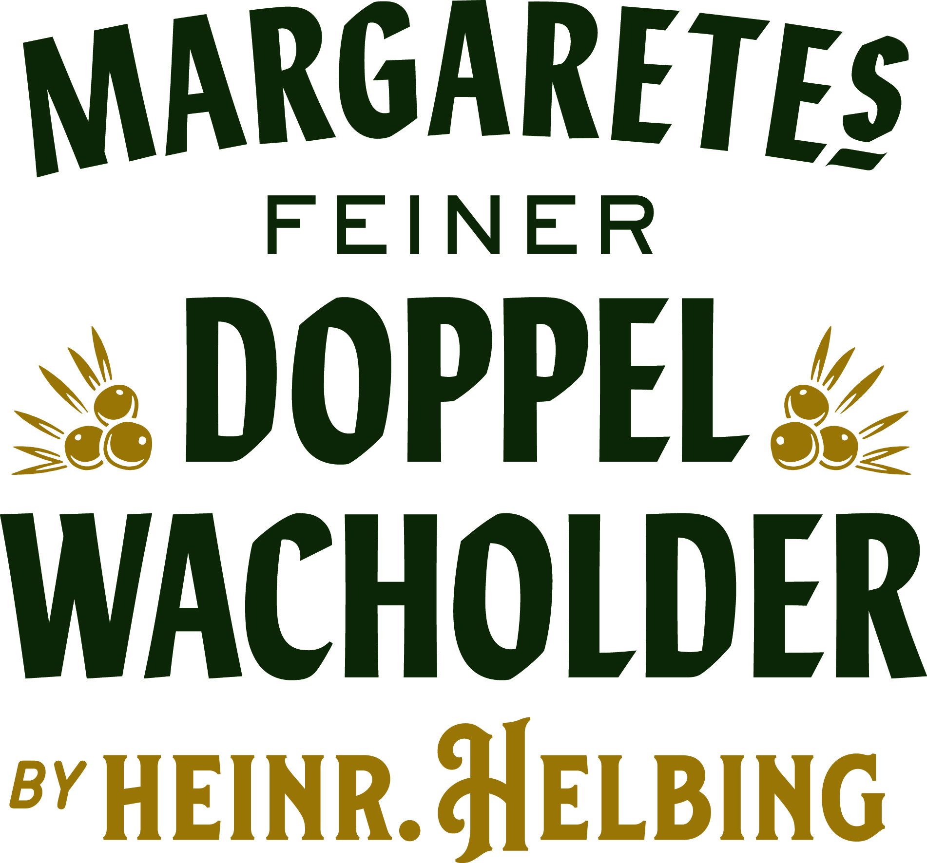

Margaretes feiner Doppel-Wacholder joins the HELBING brand family with feminine elegance and in organic quality

Hamburg, September 25th 2019. Following the launch of the HELBINGs feiner Aquavit in 2015, the HELBING brand family, with its flagship HELBING Kümmel at the top, is now joined by a juniper-flavoured, new family member on the German market, limited to a number of 10.000 bottles and to be rolled out in export markets later this year. Margaretes feiner Doppel-Wacholder, with its straight and honest character, opens up a new chapter in the rich history of the traditional and iconic HELBING Kümmel brand and breaks new ground with the six-month maturation of the distillate in juniper wood casks. As of now, Margaretes feiner Doppel-Wacholder is available in Germany at specialist retailers, in gastronomy and online shops for a RSP of 24,99€ (0,5l).
„With the launch of Margaretes feiner Doppel-Wacholder we provide the category of the popular juniper based spirits category with new impulses that will enthral mixologists, HELBING Kümmel fans and connoisseurs of specialties with a regional reference alike. This juniper-flavoured spirit pays tribute to the northern German lifestyle and at the same time honours a woman, who had courage and entrepreneurial spirit in turbulent times, thereby helping the HELBING brand to further flourish and paving the way for HELBING to become as iconic as it is today”, says Dr. Tina Ingwersen-Matthiesen, shareholder, member of the board and member of the BORCO owner family Matthiesen, who brought Margaretes feiner Doppel-Wacholder to life and has been closely accompanying the product development with excitement and passion.
Its melodious name gets Margaretes feiner Doppel-Wacholder from the fascinating woman Sophie Margarete Helbing, the widow of Christoph Heinrich Helbing who was the son of HELBING’s founding father Peter Hinrich Helbing. After his sudden death at the turn of the century and in the midst of the Industrial Revolution, Sophie Margarete took over the management of the company without hesitation, accompanied by her two sons-in-law and her oldest son. A woman at the top of a successful spirits company in the 19th century was highly exceptional and not common. Due to her determination, she was able to lay down the tracks for the unparalleled success story of HELBING, which continues to this day.

A one-of-a-kind production with organic certification and maturation in juniper wood barrels
In order to honour her dedication to the brand and her accomplishments, the HELBING family recipe of the Doppel-Wacholder from the beginning of the 20th century has been further developed and transferred to modern times. For the production only organic juniper berries are used and macerated in an organic wheat distillate. Following, the macerate is distilled in small batches in a copper pot still. Then, the distillate matures in juniper wood barrels for six months, before being merged with the organic wheat distillate, filtered and eventually bottled in nostalgic bottles. The bottles are highly adorned by an illustrated portrait of Sophie Margarete herself, adding a personal touch to the spirit.
The layout of the green, elegant label juxtaposes historic elements and modern details, such as the graphic pattern of the label’s background. Besides the origin of the Margaretes feiner Doppel-Wacholder, the label shows the details of the maturation period. Every bottle is filled by hand and is individually numbered, contributing to its exclusivity.

Further information:

APPEARANCE: clear

AROMA: straight juniper flavour, pleasantly integrated notes of alcohol and subtle notes of juniper wood barrels as well as vanilla.

TASTE: perfect balance of fresh juniper berries, vanilla, caramel and citrus.

FINISH: the juniper flavour is dominating and perfectly pairs with the citrus and vanilla notes, creating a lingering and long-lasting finish.

MIXABILITY: with its distinct juniper taste, Margaretes feiner Doppel-Wacholder reveals its charm and full flavour in combination with a dry Tonic and also with additional aromatic oils.

Caption:
Margaretes feiner Doppel-Wacholder_Dr. Tina Ingwersen-Matthiesen:
Dr. Tina Ingwersen-Matthiesen showcases the newest HELBING family member in the headquarter of the family-owned spirits company BORCO in Hamburg, Germany.

BORCO-MARKEN-IMPORT, Hamburg
Owner of Margaretes feiner Doppel-Wacholder is BORCO-MARKEN-IMPORT. Based in Hamburg, BORCO is one of the largest German and European producers and distributors of top international spirit brands. The portfolio of the family-owned and independent company, including among others SIERRA Tequila, YENI Raki, RUSSIAN STANDARD Vodka, DISARONNO, Champagne LANSON and the whiskys from WHYTE & MACKAY, covers almost all key international segments and is certainly unique in terms of its strength and unity.

For further information, please contact:
BORCO-MARKEN-IMPORT Matthiesen GmbH & Co.KG
Winsbergring 12 – 22, 22525 Hamburg
Telefon: (040) 85 31 6-0
Telefax: (040) 85 85 00
E-Mail: infoline(at)borco.com
www.borco.com

